06/18/2024
Points covered by Wendi Hartup:
- Donald Schlesselman will be the Town’s Project Coordinator.
- Cross Country season is during this Fall and many meets are held at Ivey Redmon.
- This park has events going on all the time so the winning team will need to be mindful and have communication regularly with the Town. We would like a weekly progress report.
- Surrounding neighbors are on-board for project. We anticipate that surrounding neighbors and regular park users will be curious.
- The entire area to be disturbed is owned by the Town. Would like to keep as many trees intact or at least used by the project.
- Riprap is to be avoided, if possible. This project should be natural channel design and structures should blend into the environment. Boulders are acceptable.
- Select NATIVE vegetation with key spots having larger species and bright color like yellow (not just seedlings and seed; the attention on this park warrants providing some larger perennials, shrubs and trees to provide an instant aesthetic appeal to the project). While grasses are lovely, in this instance swaths of massed grasses or flowers should be considered (ex. area of all switchgrass and bluestem but not a chaotic, natural mess of grasses with very little flowers). Think shoreline garden rather than usual natural, wild mix (we are open to ideas but also have a list of plants used in the last project). We realize this could make seed disbursement a little more complex but flowers, seasonal color and controlled aesthetics are expected by the Town. Wendi will work with winning team on plant choices as well as education of those in charge to compromise.
- All easements are platted.
- Team should expect regular on-site meetings with Donald and occasionally Wendi to work on issues.
- We’ll utilize on-site spoil as much as is feasible. Potential soil dump can be worked out at the park.
- There are several invasives that we’ll need to get rid of: privet, multiflora rose, and Stiltgrass with both a hands-on class and the contractor (we’ll get pesticide credit for this as well). The Town realizes that Stiltgrass is difficult to eradicate. The maintenance plan should include recommendations/tips on upkeep of management.
- There are several NC State Extension education classes planned that the Teams will be a part of: NCSU stream restoration construction class, livestaking, backyard stream repair, invasive ID/removal. We’ll plan those with team input. Time and materials used for classes and workshops come out of the Town of Kernersville budget, not the contract budget, and count as match.
- This project is intended to be scalable. Many rains have occurred since the feasibility studies were conducted.
- This project provides the total project budget up front. This project is funded by the NC Clean Land and Water Fund as well as the NC Division of Water Resources Development Grant, the Town is obligated to conduct the grants as approved ($100k for design/permitting/surveying and $505k for construction see below).

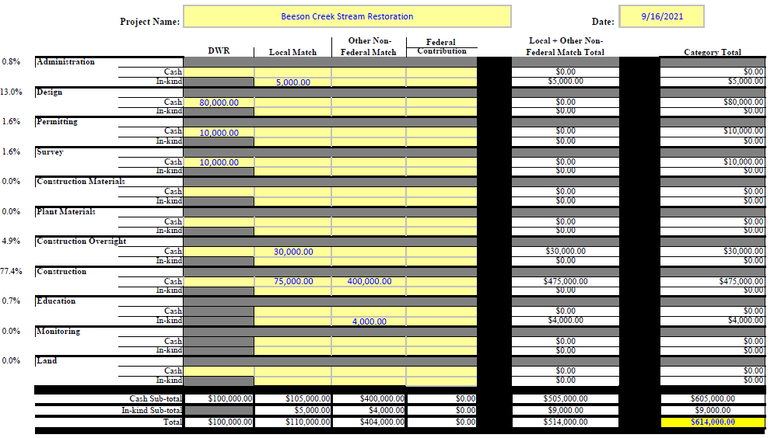
FAQ Below are some questions already received with some clarifications.
- Is the December 2nd 2024 for substantial completion of the design or of construction? Is the December 2nd 2024 date really meant to be in 2024 or should it be 2025?
The schedule is correct. Dec 2nd, 2024 is substantial completion of the construction.
Activity | Date
Issue RFQ | June 10, 2024
SOQ Preparation Period | June 10 - July 5, 2024
Proposer Meeting- Pre-SOQ Conference and Site Tour | June 18, 2024
Deadline for Questions and Comments | June 28, 2024
Submission of SOQs | July 5, 2024
Review and evaluation of SOQs | July 10 - July 19, 2024
Interviews (optional at discretion of Owner) | July 15-16, 2024
Selection of best qualified design-builder | July 19, 2024
Board of Alderman Approval August 7th, 2024 Meeting | July 31st Board Packet  August 7 BOA Meeting
Contract Execution | August 16, 2024
Deadline for Notification of Possible Delay in Schedule | October 2, 2024
Deadline for Substantial Completion | December 2, 2024
Deadline for Final Completion | January 2, 2025
Deadline for Final Warranty Inspection | January 2, 2026

August 7th is the Board of Alderman meeting where they will approve the Design-Build Team going into contract.
August 16 is when we hope to have the contract executable at the latest.
October 2, is the deadline to notify the grant funders that an extension is needed for construction substantial completion.

Note: This is a qualification-based project.

Simply put: is your team qualified and can your team do the work for the budget provided with some innovation within the limits we’ve set forth. The goal is to improve water quality and stop the erosion as best as is possible. There are so many ways to fix a creek. Reshaping and earth work are not always the best approach so try to remember that the Town would like the Team to think out of the box.
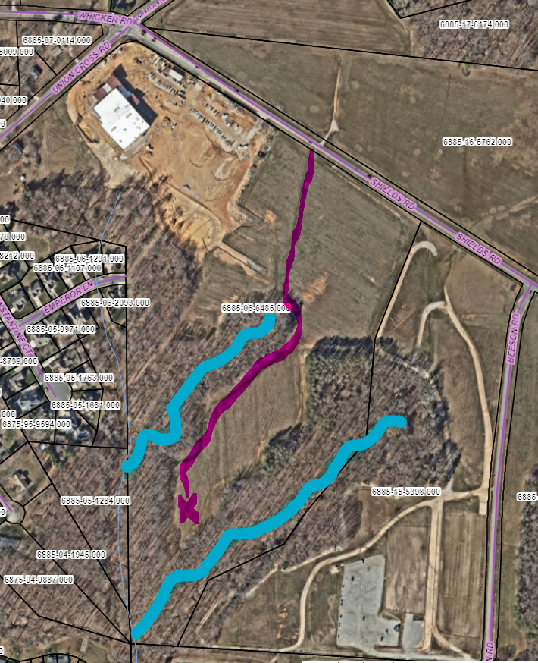
Construction entrance leading to equipment storage area.

Minutes from meeting:
- Start time: 9:05AM
- All participants signed in.
- Those in attendance:
  - Wendi Hartup, Donald Schlesselman, Megan McDowell (Town of Kernersville)
  - Brian Fernandez (North State Environmental, b.fernandez@nsenv.com)
  - Wes Newell (Resource Environmental Solutions, wnewell@res.us)
  - Geoff Smith (Wildlands Engineering, gsmith@wildlandseng.com)
- Wendi gave brief background
- Wendi covered the budget & timeframe for submittals.
- Wendi covered the site map.
- Time for questions and answers (see below).
- There was a site tour with 5 stops with questions along the way.
- Adjourned at 10:00AM

Questions during meeting:
- Q: Can the classes and workshops occur concurrently to the work being performed, specifically for the invasive treatments? A: Yes.
- Q: Has the Town exhausted all of their extensions for the grants? A: We do not believe so. The Grantors have been easy to work with in the past for grants and have been lenient.
- Q: Is there concern with the completion date being too close? The turnaround on permitting may not be realistic. A: There is some but if everything goes smoothly we think it is possible. We are also lenient on our timeframe.
- Q: Is it okay to include possible extensions to the submittal? A: When we select a contractor, we can discuss more details at that time.
- Q: Who is the representative for Land and Water? A: Steve Bevington.
- Q: Will there be trails or greenways within the project easement? A: Not at this time, but it is a possibility in the future after each reach has been restored.
- Q: We are supposed to save as many trees as we can? A: Yes, but we are understanding that many will have to go. These can be used in structures.
- Q: Is this a regulated floodplain? A: No. Downstream on the main channel has floodplain but no CLOMR will be needed according to our Town Floodplain Administrator.
- Q: Are there restrictions regarding bats. A: Not at this time but EPA is considering something for the TriColor Bat.
- Q: When was the cost estimated for this project? A: 2016
- Q: Could part of the efforts be stabilization rather than restoration? A: There are so many ways to fix a creek. Reshaping and earth work are not always the best approach so try to remember that the Town would like the Team to think out of the box. We will have to work the grant folks and the budget we have.
- Q: Where is the borrow area? A: We can coordinate with the park for the best options.
- Q: Is it okay to send other staff to the site to assess the project? A: Yes, the Town owns the whole project area.

Other discussion during meeting:
- There is sand rock from the cross-country track that washes into the creek.
- Project will be billed monthly.
- The Department of Ag is treating the area for Spotted Lanternfly on the Tree of Heaven.
- We walked down the construction entrance. The park does not use the area shown in the map so they are flexible as to how it can be established. It is to be turned back to grass after project completion unless otherwise instructed by the park.
- Work can be performed on weekdays, and weekends during the day.
- There is a possibility of the contractor being asked to attend a Board of Aldermen meeting. The Aldermen may also visit the project (coordinated by the Stormwater Manager).

